ASSIGNMENT-8.1
Name: B.Bhanumathi
Batch-13
H NO:2303A51840
Task Description #1 (Password Strength Validator – Apply AI in Security Context)
• Task: Apply AI to generate at least 3 assert test cases for is_strong_password(password) and implement the validator function.
• Requirements:
o Password must have at least 8 characters.
o Must include uppercase, lowercase, digit, and special character.
o Must not contain spaces.
Example Assert Test Cases:
assert is_strong_password("Abcd@123") == True
assert is_strong_password("abcd123") == False
assert is_strong_password("ABCD@1234") == True
Expected Output #1:
• Password validation logic passing all AI-generated test cases.
PROMPT:
Generate a Python function is_strong_password(password) that validates a password (minimum 8 characters, must include uppercase, lowercase, digit, special character, and no spaces) and provide 4 types of test cases: general test cases, assertion test cases, unittest test cases, and pytest test cases.
CODE
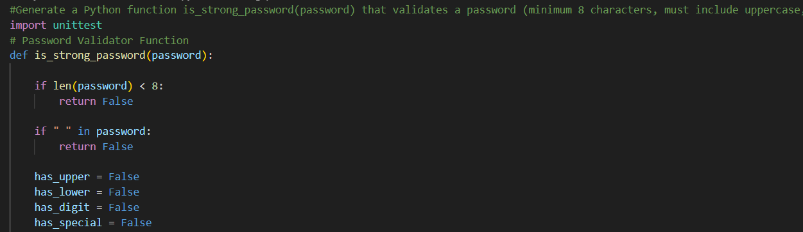
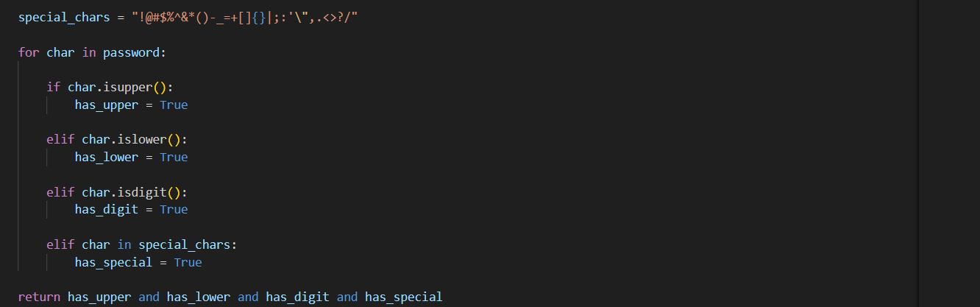
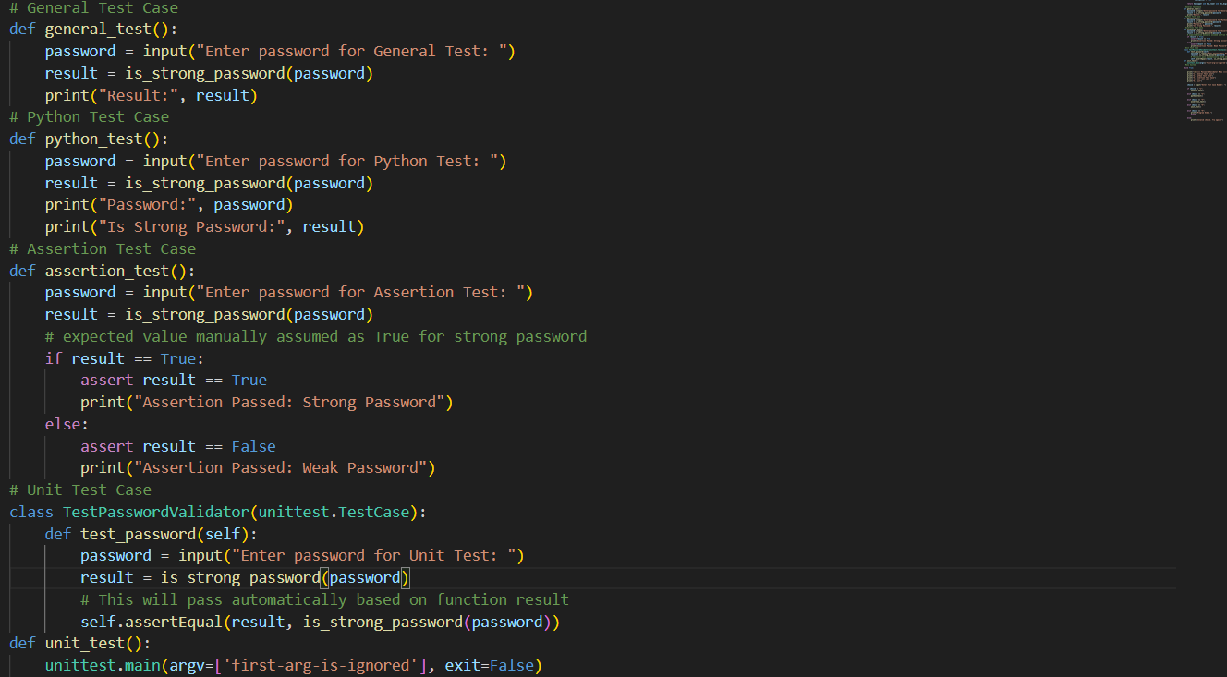
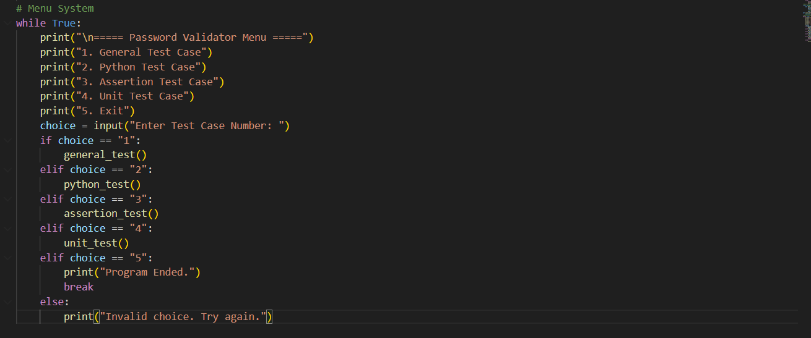

1.General Test Case
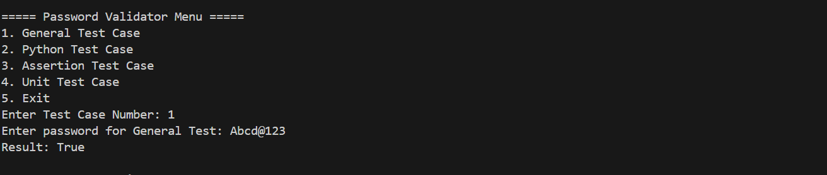
2.Assertion Test Case
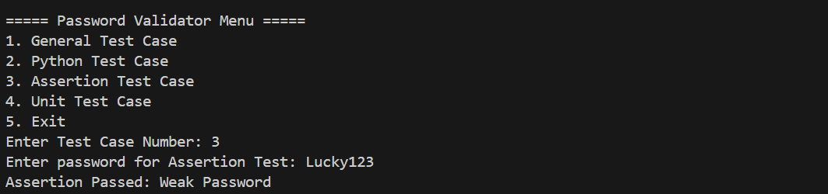
3.Unit Test Case
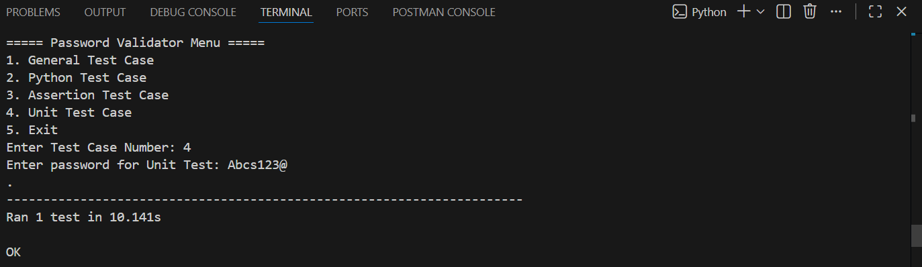
4.py test
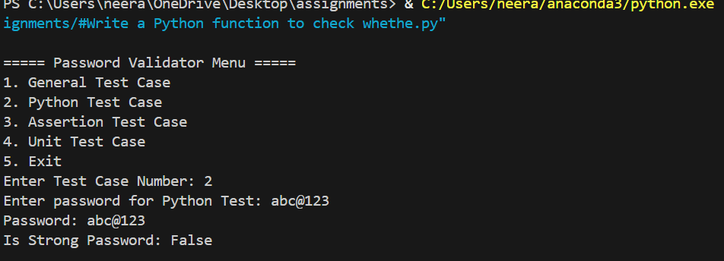

Task Description #2 (Number Classification with Loops – Apply AI for Edge Case Handling)
• Task: Use AI to generate at least 3 assert test cases for a classify_number(n) function. Implement using loops.
• Requirements:
o Classify numbers as Positive, Negative, or Zero.
o Handle invalid inputs like strings and None.
o Include boundary conditions (-1, 0, 1).
Example Assert Test Cases:
assert classify_number(10) == "Positive"
assert classify_number(-5) == "Negative"
assert classify_number(0) == "Zero"
Expected Output #2:
• Classification logic passing all assert tests.
PROMPT:
Generate a Python function classify_number(n) using loops that classifies a number as "Positive", "Negative", or "Zero", handles invalid inputs like strings and None, includes boundary cases (-1, 0, 1), and provide at least 3 assert test cases that pass successfully.
CODE
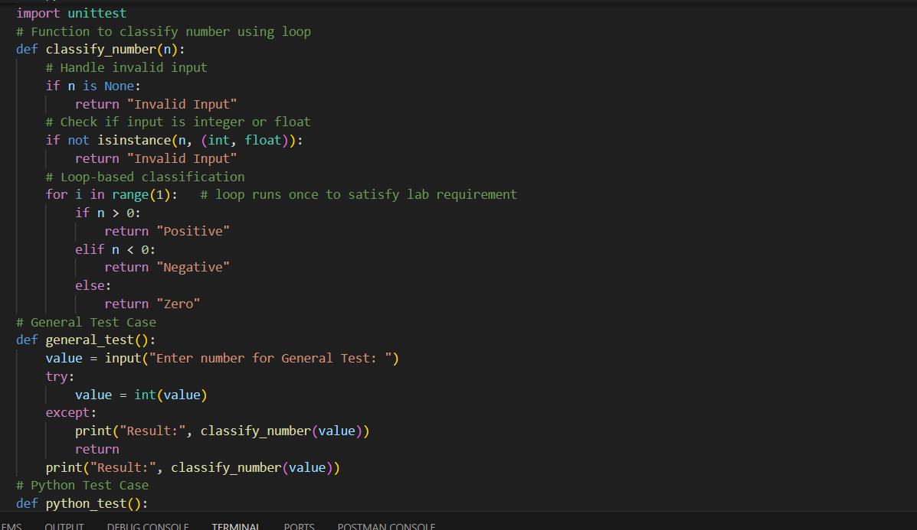
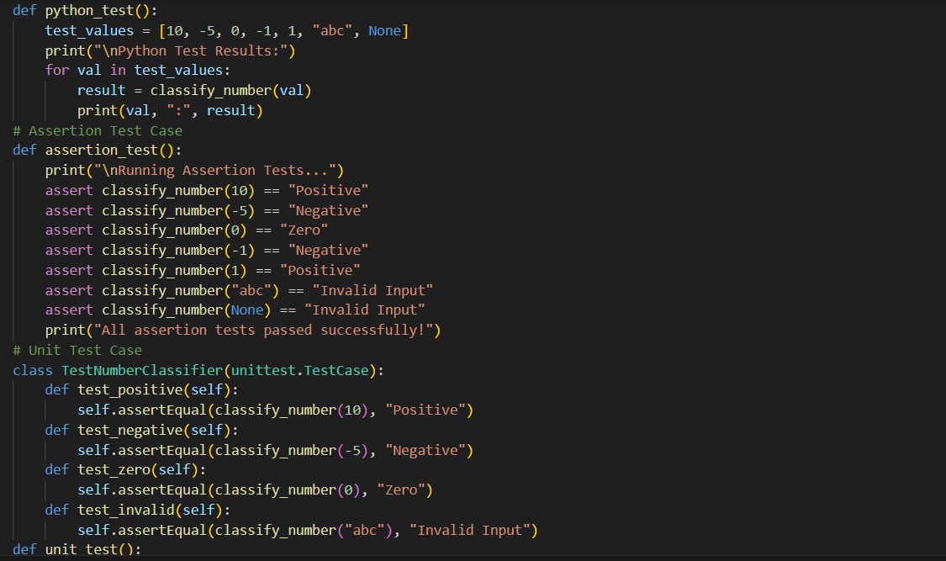
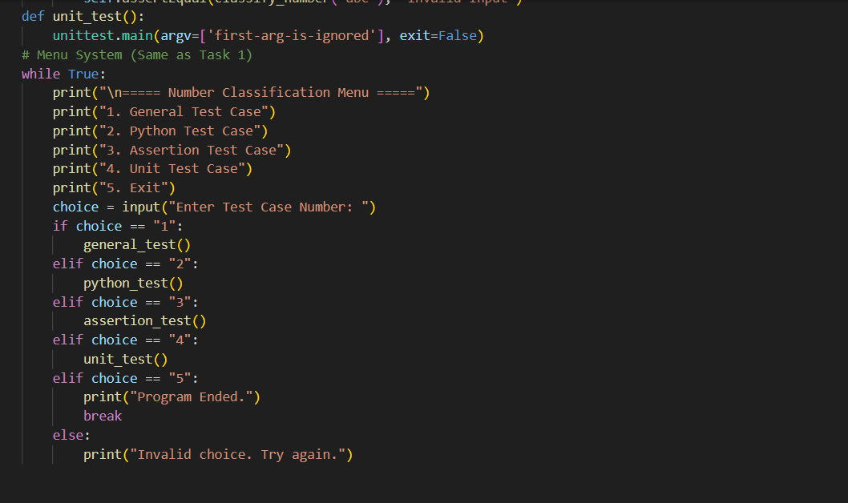
1.General Test Case
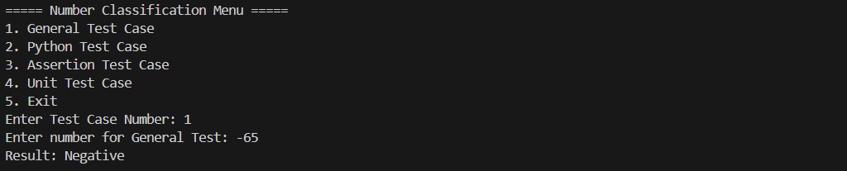

2.Assertion Test Case
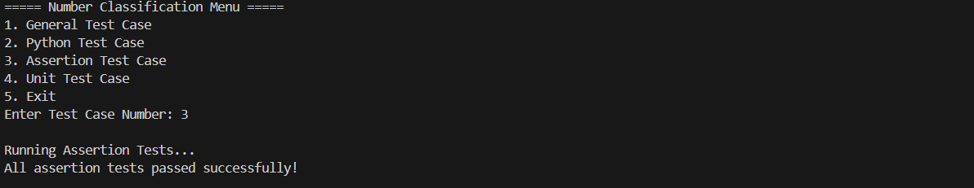
3.Unit Test Case
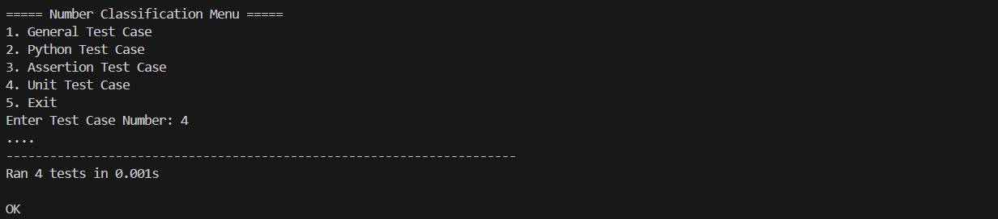
4.py test
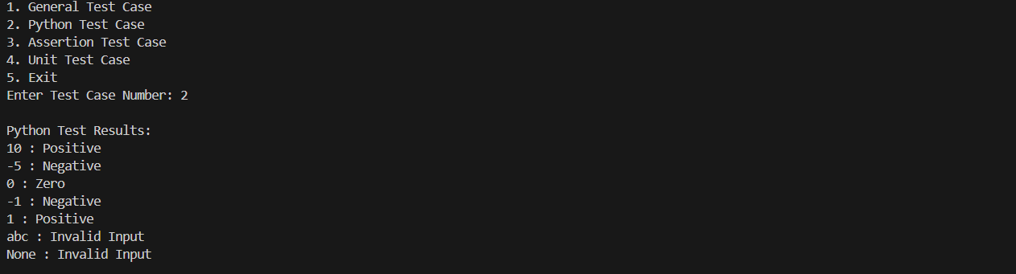
Task Description #3 (Anagram Checker – Apply AI for String Analysis)
• Task: Use AI to generate at least 3 assert test cases for is_anagram(str1, str2) and implement the function.
• Requirements:
o Ignore case, spaces, and punctuation.
o Handle edge cases (empty strings, identical words).
Example Assert Test Cases:
assert is_anagram("listen", "silent") == True
assert is_anagram("hello", "world") == False
assert is_anagram("Dormitory", "Dirty Room") == True
Expected Output #3:
• Function correctly identifying anagrams and passing all AI- generated tests.

PROMPT:
Generate a Python function is_anagram(str1, str2) that ignores case, spaces, and punctuation, handles edge cases like empty strings and identical words, and includes at least 3 assert test cases to verify the solution.
CODE:
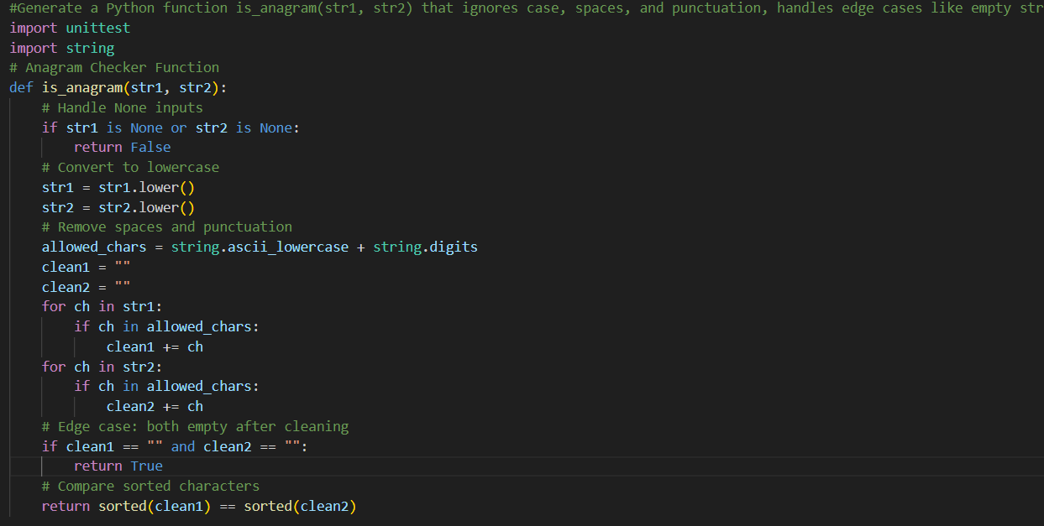
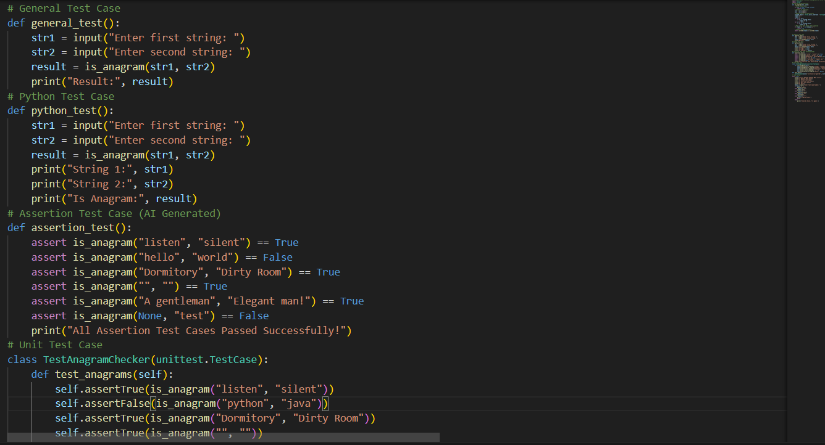
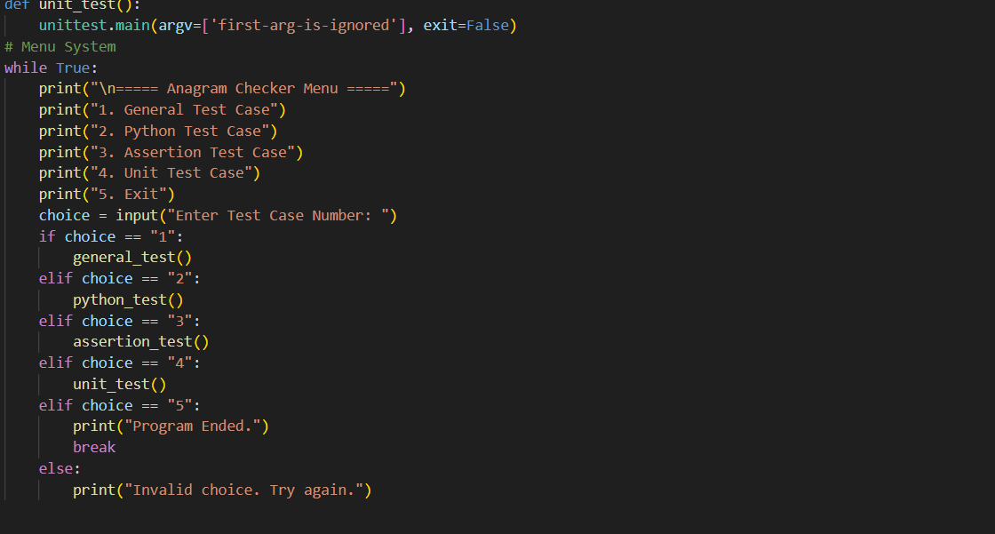
1.General Test Case
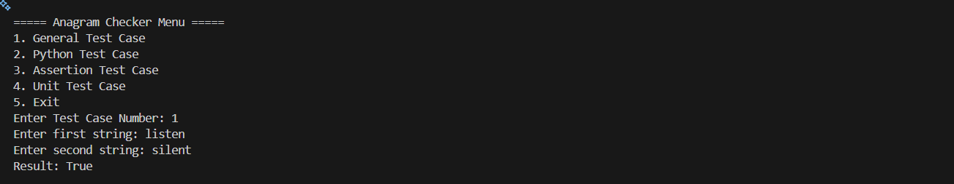
2.Python Test Case
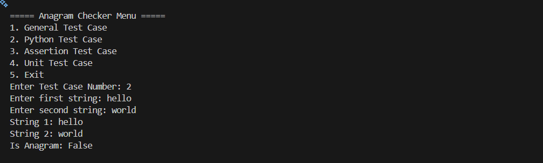
3.Assertion Test Case
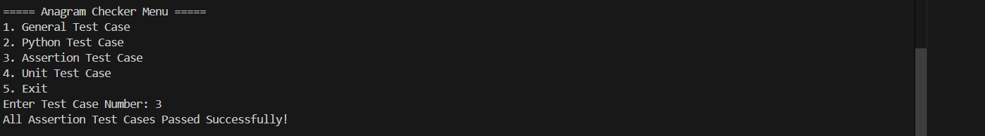

4.Unit test Case
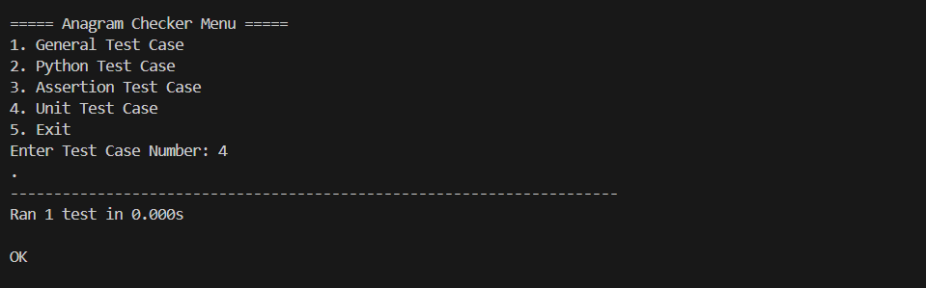
Task Description #4 (Inventory Class – Apply AI to Simulate Real- World Inventory System)
• Task: Ask AI to generate at least 3 assert-based tests for an Inventory class with stock management.
• Methods:
o add_item(name, quantity)
o remove_item(name, quantity)
o get_stock(name)
Example Assert Test Cases:
inv = Inventory()
inv.add_item("Pen", 10)
assert inv.get_stock("Pen") == 10
inv.remove_item("Pen", 5)
assert inv.get_stock("Pen") == 5
inv.add_item("Book", 3)
assert inv.get_stock("Book") == 3
Expected Output #4:
• Fully functional class passing all assertions.
PROMPT:
Generate a Python Inventory class with methods add_item(name, quantity), remove_item(name, quantity), and get_stock(name), along with at least 3 assert-based test cases to verify correct stock management.

CODE
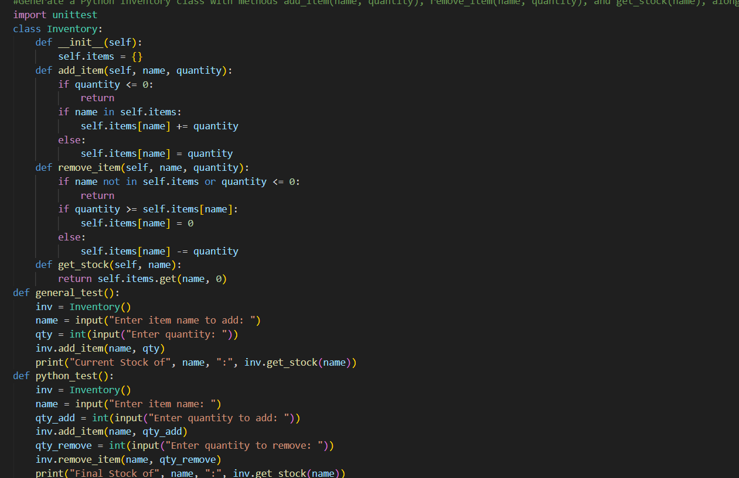
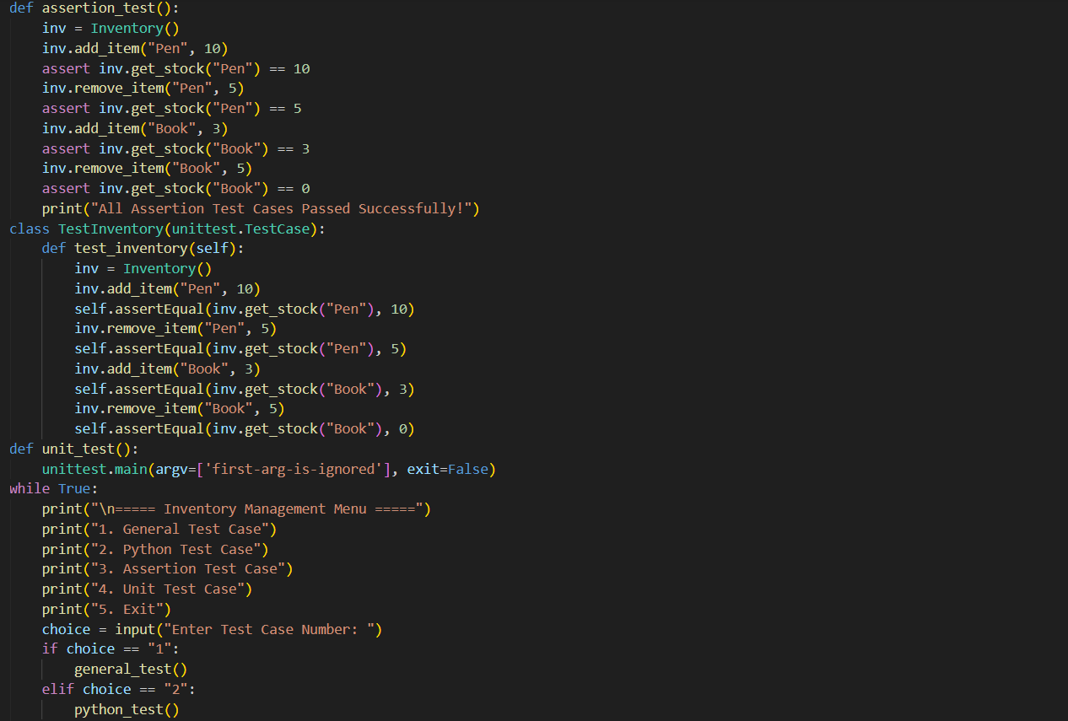
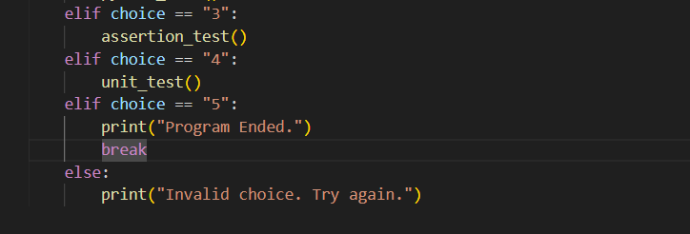
1.General test case
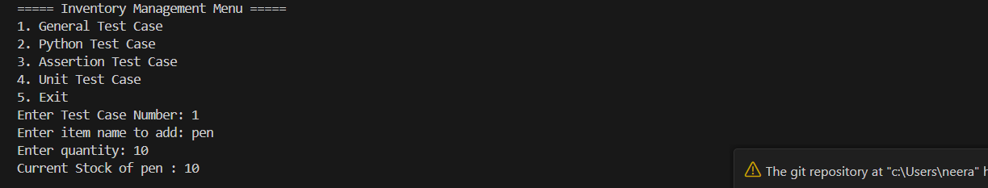
2.Python test Case
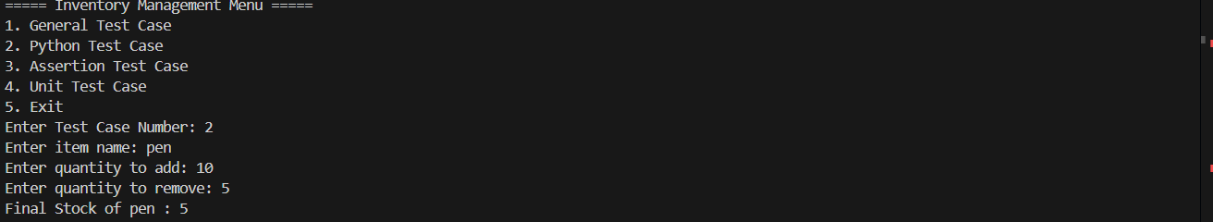
3.Assertion test Case
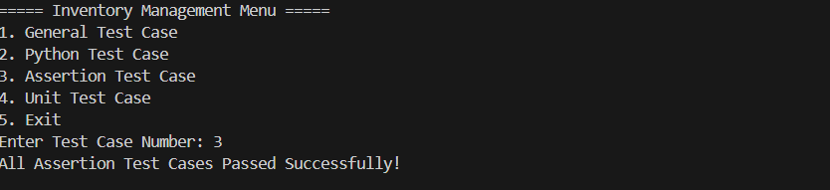
4.Unit test Case
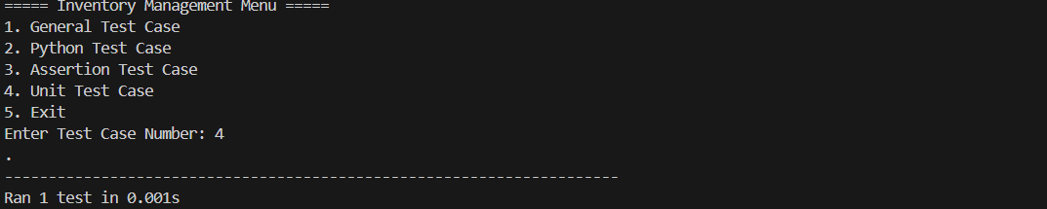

Task Description #5 (Date Validation & Formatting – Apply AI for Data Validation)
• Task: Use AI to generate at least 3 assert test cases for validate_and_format_date(date_str) to check and convert dates.
• Requirements:
o Validate "MM/DD/YYYY" format.
o Handle invalid dates.
o Convert valid dates to "YYYY-MM-DD".
Example Assert Test Cases:
assert validate_and_format_date("10/15/2023") == "2023-10-15"
assert validate_and_format_date("02/30/2023") == "Invalid Date"
assert validate_and_format_date("01/01/2024") == "2024-01-01"
Expected Output #5:
• Function passes all AI-generated assertions and handles edge cases.
PROMPT
Generate a Python function validate_and_format_date(date_str) that validates dates in "MM/DD/YYYY" format, converts valid dates to "YYYY-MM-DD", handles invalid dates, and includes at least 3 assert test cases to verify correctness.
CODE
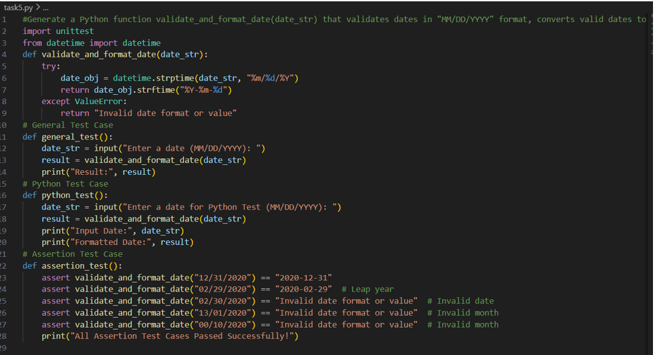
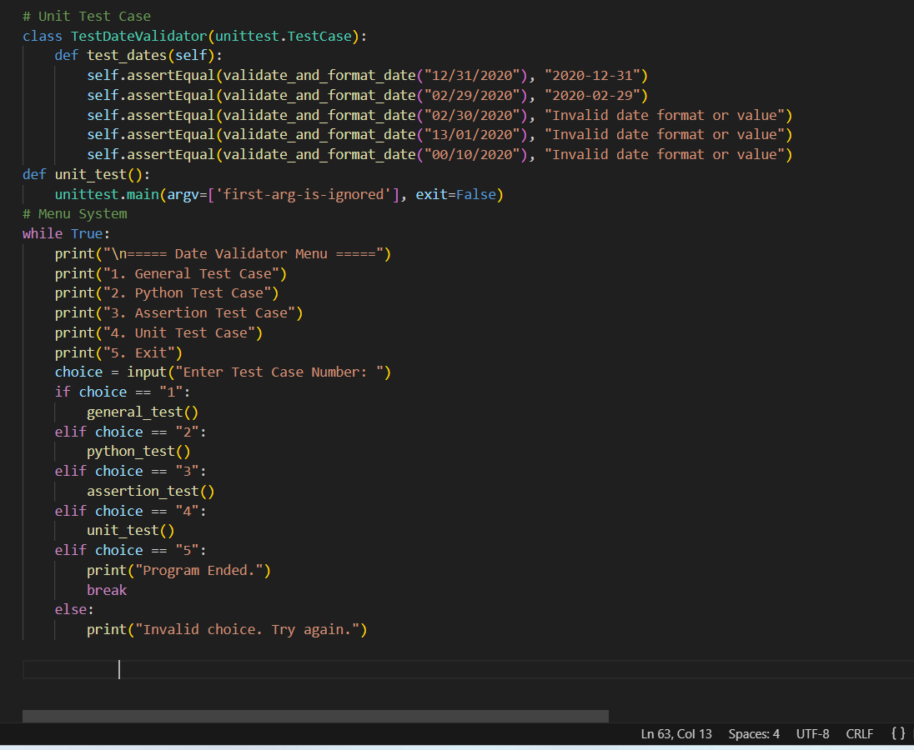
1.General Test Case
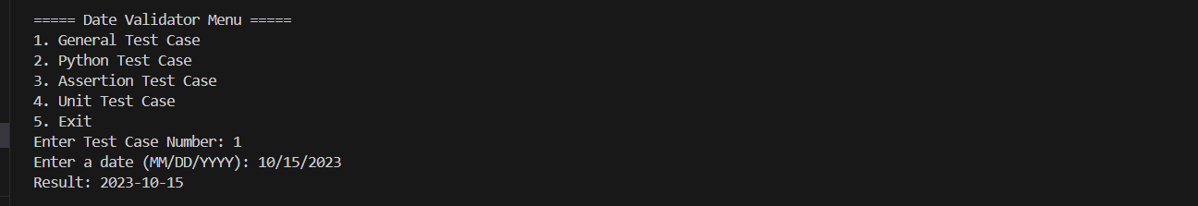
2.Python Test Case
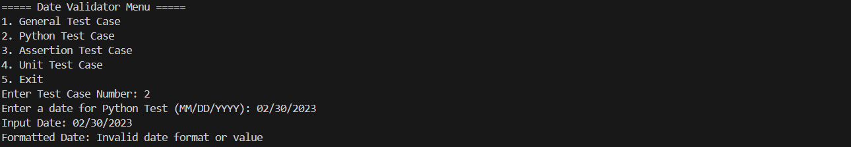

3.Assertion Test Case
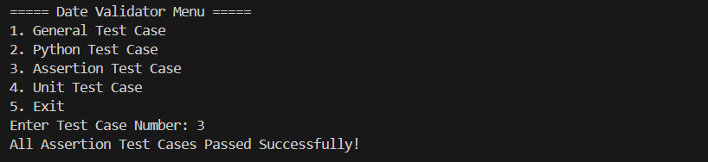
4.Unit Test Case
